**INTERNATIONAL UNIVERSITY VNUHCM**

PRINCIPLES OF PROGRAMMING LANGUAGES

**LAB 5. PYTHON COLLECTIONS**

**PURPOSE:** After this lab, you are able to use Python collections.

**EXERCISES:**

L5E1. Practise Python collections, including *lists, tuples, sets* and *dictionaries,* by using the following tutorials and examples:

Lists: <https://www.w3schools.com/python/python_lists.asp>

Tuples: <https://www.w3schools.com/python/python_tuples.asp>

Sets: <https://www.w3schools.com/python/python_sets.asp>

Dictionaries: <https://www.w3schools.com/python/python_dictionaries.asp>

L5E2. Create Symbol Tables[1] for Exercises L2E1 and L2E2.

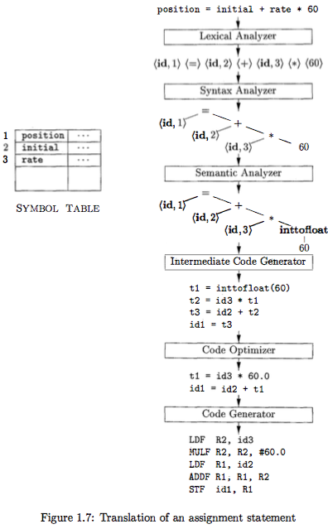

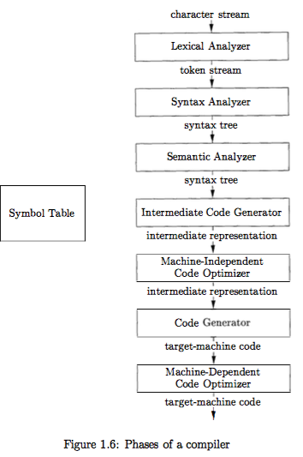

1. A part of a compilation process mentioned Figure 1.6 and Figure 1.7 in (Aho et. al., 2007)